

The Gaming Room

CS 230 Project Software Design Template
Version 1.0

Table of Contents

CS 230 Project Software Design Template 1
Table of Contents 2
Document Revision History 2
Executive Summary 3
Requirements 3
Design Constraints 3
System Architecture View 3
Domain Model 3
Evaluation 4
Recommendations 5

Document Revision History

Version | Date | Author | Comments
1.0 | 09/30/2026 | Jay Laws | Recommendations for program completed

Executive Summary

Park Station Manufacturing is looking to have a program on which they can create video clips. These clips can then be used by customers that can utilize the videos for training and educational purposes. We intend to create a product that meets the clients’ requirements while also addressing compatibility issues.

Requirements

The system must be available on Mac and needs to be able to produce high-quality videos for customer use. We also want to make sure that the product is user friendly and accessible by the client and its staff.

Design Constraints

The client currently uses the Microsoft operating system but needs the program to be compatible with Mac operating system. This limits us in what hardware and software that can be used in order and may impact the video quality. Since the client uses Windows, staff are constrained in what type of product they provide and how the customer interacts with the system. They also must be trained in how to use the MacOS and how to convert from Windows to MacOS.

System Architecture View

Not Applicable

Domain Model

This diagram shows how the game we are creating will be structured. The application consists of seven classes in order to control the tournament. The games are structured in teams that contain players. The Entity is where identification information is contained such as the name and id. Both teams and players have a name and id to differentiate them from one another. As a programmer we have created one main scheme that the program follows instead of having to set up three different entities. This is done for inheritance purposes that is an objective of object-oriented programming that allows for reusability. The GameService is the main part of the system that keeps track of all games. It assigns ID numbers one at time to players, teams and games so there are no duplications. The ProgramDriver starts the application and the SingletonTester is where the program checks to make sure everything is working smoothly and there are no duplications. In this system Games contain Teams and Teams consist of players each with their own name and id. The layout provided allows room to add more games and players in the future without changing the integrity of the system.

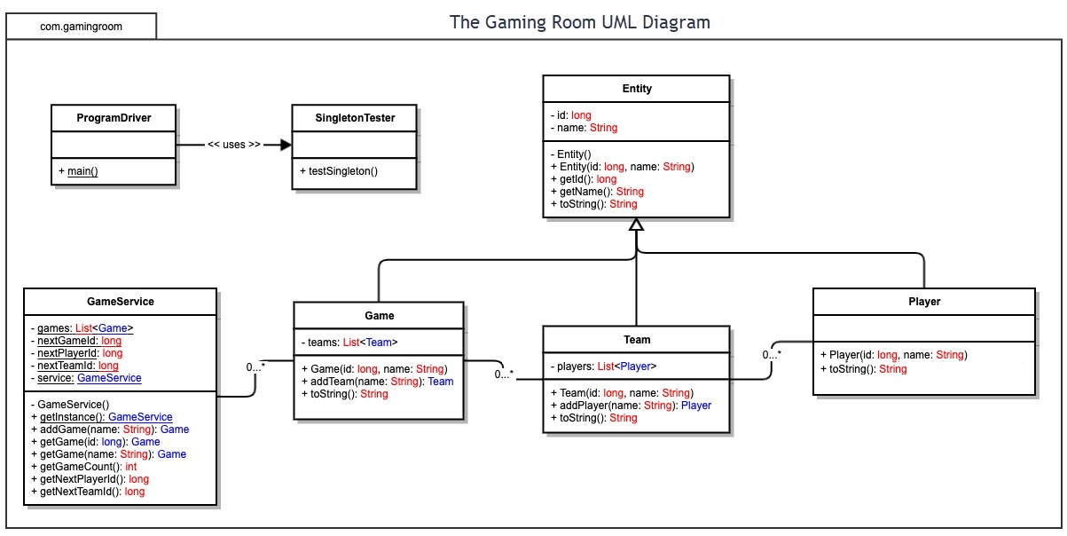

Evaluation

Development Requirements | Mac | Linux | Windows | Mobile Devices
Server Side | Uses Unix which is and can run on software such as Apache which is both reliable and flexible. It also works on both Linux and Windows for transferability. Known for its security features and graphic capabilities. Mac hardware and software is more expensive for its competitors. It proprietary software makes it so certain programs can only be used on their platform. | Uses Linux which is similar to MacOS server Unix. The open-source operating system makes it available to everyone for customization. Known for reliability without the need to restart over long periods of time. Those unfamiliar with the system may need additional training in its complexity. There are also different versions of the system making technical issues more complicated. | Uses the Windows server by Microsoft. Common on most computers. Easy to use and is more familiar than other servers. Provides support and documents to learn features of the system and is less costly than Mac. Although less costly than Mac, some licensing can become costly making it more expensive than Linux. | Convenient and easy to access. Can be used to test web applications. Disadvantages are that they have small storage capabilities and low processing power.
Client Side | Popular browsers such as Chrome, Firefox and Safari can be accessed by users. A disadvantage is that the program may not work correctly if done originally under a Windows programming format. An advantage to using Mac is that it provides additional options for programming with Safari being available. This allows more opportunities for debugging and testing systems. | Browsers such as Chrome and Firefox can be used. Compatibility is sometimes an issue since Linux is less popular. An advantage is that Linux is free and more customizable. It also has added security with strong user permissions and features. | Browsers such as Chrome, Microsoft Edge, and Firefox are available for use and more common. Supports most hardware and software and widely used by most consumers. Some disadvantages are that different users may have different versions of the Windows platform. There may be features that are unavailable on older versions of the system. Security updates are common which may require additional testing. | Popular browsers can be found in mobile form such as Chrome for Androids and Safari for iPhone. They are portable and accessible from any location where the device has an internet signal.
Development Tools | Supports Python and Java but not C++. Apple has its own IDE called Xcode for writing code, creating applications and debugging programs. | Supports the top programming languages such as Python, Java and C++. IDE’s available include Visual Studio, Eclipse and IntelliJ IDEA | Supports most programming languages such as C++, Java and Python. Visual Studio, Eclipse and IntelliJ IDEA are available IDE’s. | Less programming languages and IDE’s are available than other operating systems. Tools such as Java and HTML are available. Visual Studio Code can be used on mobile devices.

Recommendations

Analyze the characteristics of and techniques specific to various systems architectures and make a recommendation to The Gaming Room. Specifically, address the following:

- Operating Platform: We recommend Windows as an operating platform for The Gaming Room as an initial option that can expand Draw It or Lose It to other computing environments.

- Operating Systems Architectures: Using Windows allows for more processing power and is used widely by consumers. It is less costly than MacOS and software is easier to access with less proprietary issues. Since Windows allows multiple programs to run at once it provides more processing power and the ability to multitask.

- Storage Management: Windows uses a file system that provides storage for the application. It also has the ability to expand storage through hard drives or use of the Cloud.

- Memory Management: RAM and internal memory comes standard with the Windows system. This will allow the program to run without freezing or interruption from other programs that may be in use.

- Distributed Systems and Networks: Draw It or Lose It can use a network connection to allow users on any platform to communicate with the game. The game can manage information online and still allow the user to access the game through their device. Unfortunately, if internet access is lost the user may lose connection to the game. On the other hand, if there is an outage the system will be notified and because we are using Windows the turnaround time to fix these issues is minimal. HTTPs in the system protects user information as it transfers between the gaming system and the customers device.

- Security: Windows HTTPs provides security and encryption between systems and protects user information. There are also firewalls and users are able to set their own permissions through their device. Unauthorized users are handled by setting up each user with its own username and password. This information is secure and stored to only allow access by those that the user provides this information to.

